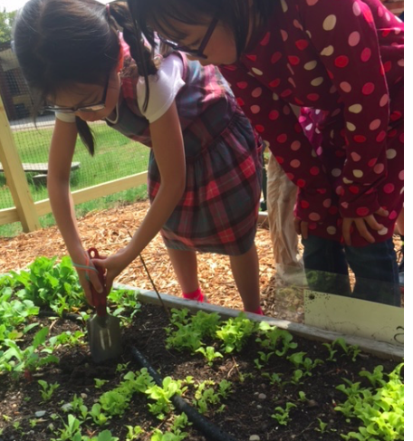
Growing Together:
Gardening With Children

For: Happy Hollow School Students in Grades 2-5
Location: Happy Hollow School, Room 6
Dates: Five Fridays, April 7, 28, May 5, 12, 19, 2017)

Time: 3:00 - 4:30 pm
Fee: $85, including materials

Instructor: Ms. Niles with Guest Gardeners
Minimum/Maximum: 6/10
Registration Deadline: Friday, March 24, 2017
SNACK INFO: Please send a nut-free snack.

Growing Together: Gardening With Children
What better way to connect children with the natural world than to bring them outside and into the garden? Ms. Niles will guide students in planting, watering, weeding, composting, and illustrating the joys of gardening! Through engaging, garden-related activities, students will:

- Help prepare the soil at Happy Hollow for a long season of productive gardening
- Experience the water cycle/water conservation by making a small terrarium to take home. Practice finding weeds… through a look at desirable vs. undesirable plants
- Compare seeds for various vegetables and flowers (you can learn a lot from a seed!)
- Help to plant the seeds for our school gardens
- Express their appreciation for the Earth through looking at artwork and painting
- Take responsibility for a plant of their choice by taking it home - with instructions

Please fill out the registration form and return with a check for $85 payable to WSCP. In the memo section of your check, write “Gardening Program.” Please send registration form and payment to:

Wayland School Community Programs

47 Loker Street

Wayland, MA 01778
WSCP Information #: 508-358-8617

Registration Form

Happy Hollow School Spring 2017 Growing Together: Gardening with Children

Student Information

Child’s Name _____________________ Grade ___ Teacher_________________

Parent/Guardian’s Name _____________________________

Cell Phone ________________ Home Phone ________________

Email _________________ Home Address _______________________________

Emergency Contact Name______________________________________________

Cell Phone ________________Home Phone ________________

Allergy Information:

Please list any allergies, including food allergies. ____________________________________________________________
____________________________________________________________________________________________________________________________________________________________________________________

Please list any medications taken regularly. _________________________________________
_____________________________________________________________________________

Please Initial Below

_____ I agree to allow my child to be photographed/videotaped during the Gardening Together: Gardening with Children class for possible use in brochures, newspapers, program websites and local cable television.

_____ I do not agree to allow my child to be photographed/videotaped during the Gardening Together: Gardening with Children class.

_________________________________________ _______________________
Signature of Parent/Guardian Date

